

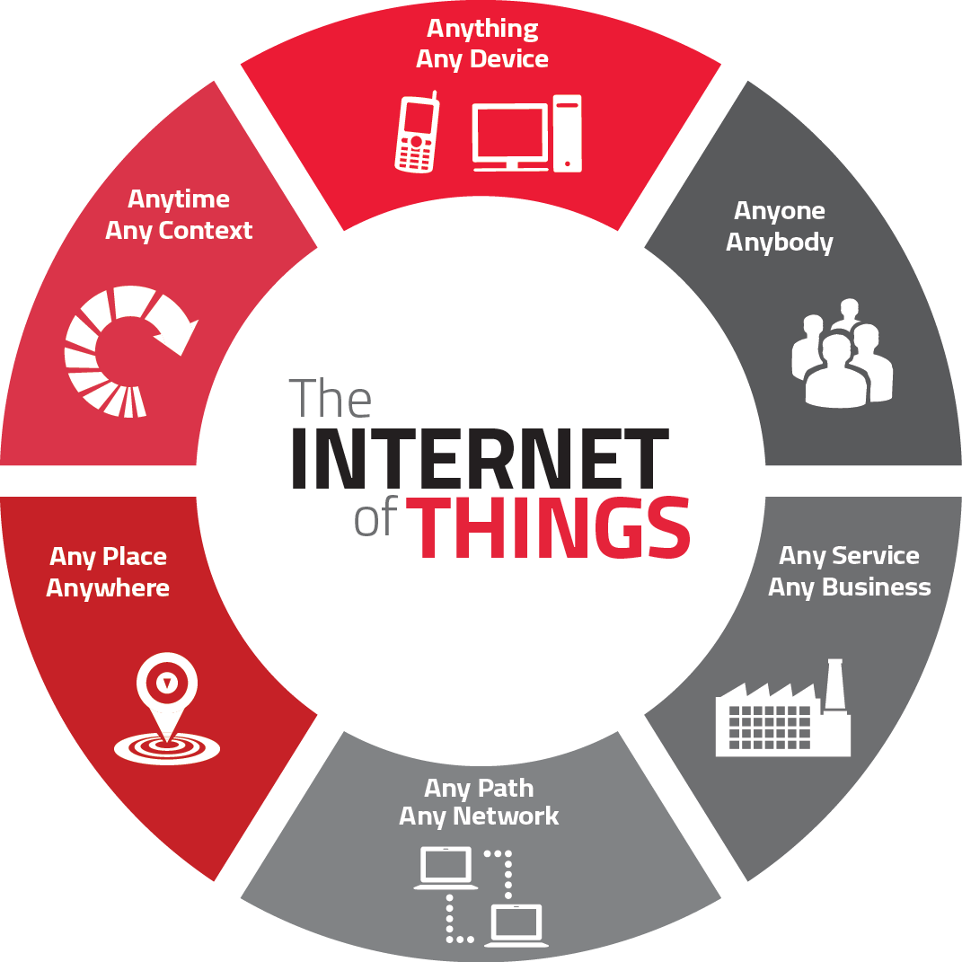

**Introduction**

The Internet of Things (IoT) is a concept in which surrounding objects are connected through wired and wireless networks without user intervention. In the field of IoT, the objects communicate and EXCHANGE information to provide advanced intelligent services for users.

This project deals with the problem of Waste management in smart cities, where the garbage collection system is not optimized. This project enables the organizations to meet their needs of smart garbage management system. This system allows the user to know the fill level of each garbage bin in a locality or city at all time, to give a cost effective and time saving route to the truck drivers.

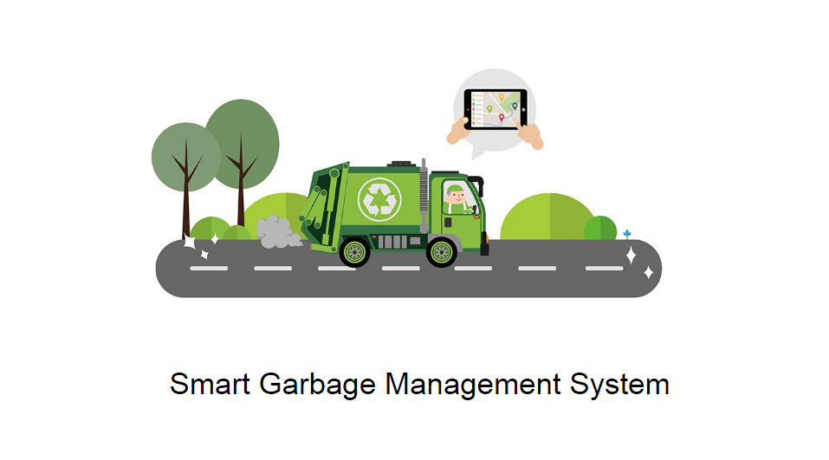

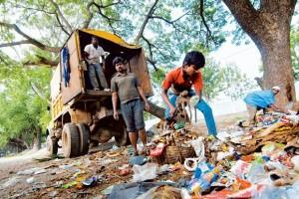

Solid Waste Management In India

* Domestic waste  thrown  on streets
* Trade waste on roads / streets
* Construction  waste  are left  unattended
* Biomedical wastes are  disposed into  municipal waste stream
* Industrial waste often disposed of in open areas

In waste management, Segregation of recyclable waste not done properly at source. Initial waste collection not done at place of generation. Design & location of municipal waste storage  depots inappropriate, resulting in littering of garbage . Street sweeping is not done everyday. Waste  transportation is done in open vehicles. Waste  processing  partially  practiced  in 35 ulbs only. The final disposal  is done through crude dumping.  Waste pickers collect  recyclables  from municipal bins and dumpsites and litter the waste  causing insanitary conditions.

* India’s Population  =  1027 Million  (as per 2001 Census)
* Urban Population  =  285 Million
* Urban Areas  =  5161 (Cities / Towns)

**Magnitude Of Problem**

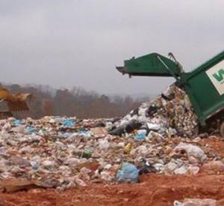

Solid Waste Management

Per capita waste generation increasing by   1.3% per annum. With urban population is increasing between   3– 3.5% / annum. Annual increase in waste generation is around 5% annually. India produces 42.0 million tons of   municipal solid waste annually at present. Per capita generation of waste varies from   200 gm to 600 gm per capita / day. Average of waste generation rate is 0.4 kg per capita per day in 0.1 million plus towns. Collection efficiency is between 50% to   90% of solid waste generated. Urban Local Bodies spend Rs.500/-   to Rs.1500/- per ton on solid waste   management of which,   60-70% of the amount is on   collection alone   20% – 30% on transportation.  No fund is spent on treatment and disposal of waste. Crude dumping of this waste is practiced in most of the cities.

[**Quantity**](https://civildigital.com/solid-waste-management-in-india/)**Of Waste Generation**

Total quantity of solid waste Generated in urban   areas  per day (tpd) Of the country –  1.15 lakh tonne. Waste generated in 6 mega cities –  21,100 tpd, 18.35%. Waste generated in metro cities  (1 million plus towns)- 19,643 tpd , 17.08%. Waste generated in  other,Class-i towns(0.1 million  plus towns)   42,635.28 tpd  37.07%. If waste produced in all the class-i cities is tackled, total percentage of waste scientifically managed would be 72.5% of total waste.

**Characteristics of Municipal Solid Waste**

* Compostable / Bio-degradable =  30% – 55%matter  (can be converted into manure)
* Inert material      =  40% – 45% (to   go to landfill)
* Recyclable materials      =  5% – 10%   (Recycling)

These percentages differ from city to city depending upon food habits

**Reasons of**[**Improper**](https://civildigital.com/solid-waste-management/)**Management Of Waste**

* Improper planning for waste management while planning the townships
* Impractical institutional set up for waste management and planning and designing in urban local bodies
* Lack of technical and trained manpower
* Incomplete community involvement
* Less expertise and exposure to the city waste management using modern techniques and best practices
* Partial awareness creation mechanism
* Outdated Management Information Systems
* Less funds with ULBs
* Indifferent attitudes of ULBs in user charges and sustainability

**Ideal Approaches To Waste Management**

1.  Possible Waste Management Options :

* (a)  Waste Minimisation

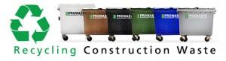

construction waste recycling

* (b)  Material Recycling
* (c)  Waste Processing (Resource Recovery)
* (d)  Waste Transformation
* (e)  Sanitary Landfilling – Limited land availability is a constraint in Metro cities.

2.  Processing / Treatment should be  :

* (i)  Technically sound
* (ii)  Financially viable
* (iii)  Eco-friendly / Environmental friendly
* (iv)  Robust operate & maintain by local community
* (v)  Long term sustainability

**Approaches To Waste Processing & Disposal**

I  Wealth From Waste (Processing Of Organic Waste)

  (A)  Waste To Compost

  (I)  Aerobic / Anaerobic Composting

  (II)  Vermi-composting

  (B)  Waste To Energy

  (I)  Refuse Derived Fuel (Rdf) / Pelletization

  (Ii)  Bio-methanation

II  Recycling [Of](https://civildigital.com/green-chemistry-history-principles-diagram/) Waste

III  Sanitary Landfilling

IV  Treating Bio-medical Waste Separately.

**Various Technology Options Recommended For Waste Processing**

Towns Generating Garbage

* Upto 50 Metric Tons / Day(mt/Day) =  Vermi-composting
* Between 50 Mt & 500 Mt / Day   =   Vermi-composting +  Mechanical Composting
* More Than 500 Mt / Day  =    Mechanical Composting +  Refuse Derived Fuel(rdf)  From Rejects Keeping In View The Type Of The City  (Industrial Or  Non- Industrial) Or Bio-methanation

**Initiatives By Government Of India**

1. Bio-medical Waste Handling Rules, 1998 –  Notified
2. Municipal Solid Waste Management Rules,   2000 – Notified.
3. Reforms Agenda  (Fiscal, Institutional, Legal)
4. Technical Manual on Municipal Solid Waste   Management
5. Technology Advisory Group on Municipal   Solid   Waste Management
6. Inter-Ministerial Task Force on Integrated   Plant   Nutrient Management from city   compost.
7. Tax Free Bonds by ULBs permitted by   Government  of India
8. Income Tax relief to Waste Management agencies
9. Public-Private Partnership in SWM
10. Capacity Building
11. Urban Reforms Incentive Fund
12. Guidelines for PSP and setting up of Regulatory   Authority
13. Introduction of Commercial Accounting System in  ULBs & other Sector Reforms
14. Model Municipal Bye-Laws framed / circulated for   benefit of ULBs for adoption
15. Financial Assistance by Government of India –   12th Finance Commission Grants

**Main issues**

–  Absence of segregation of waste at source

–  lack of technical   expertise   and       appropriate   institutional arrangement

–  Unwillingness of ulbs to introduce proper  collection,    segregation, transportation   and   treatment / disposal systems

–  Indifferent attitude of citizens towards   waste   management due to lack of awareness

–  Lack of community participation towards   waste   management and hygienic conditions

–  Lack of funds with ulbs

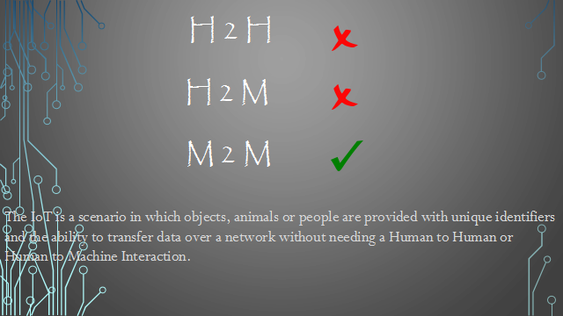

H2H not needed

H2M not needed

M2M not needed



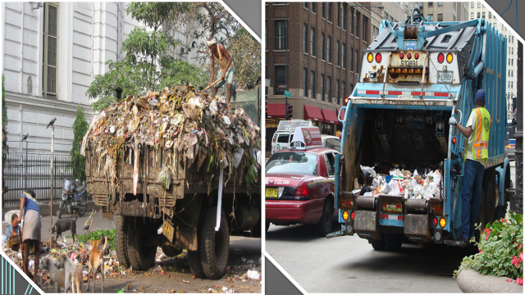

**1. OBJECTIVES**

The key research objectives are as follows:

• The proposed system would be able to automate the solid waste monitoring process and management of the overall collection process using IOT (Internet of Things).

• The Proposed system consist of main subsystems namely Smart Trash System(STS) and Smart Monitoring and Controlling Hut(SMCH).

• In the proposed system, whenever the waste bin gets filled this is acknowledged by placing the circuit at the waste bin, which transmits it to the receiver at the desired place in the area or spot.

• In the proposed system, the received signal indicates the waste bin status at the monitoring and controlling system.

**2. Design Implementation and DFD**

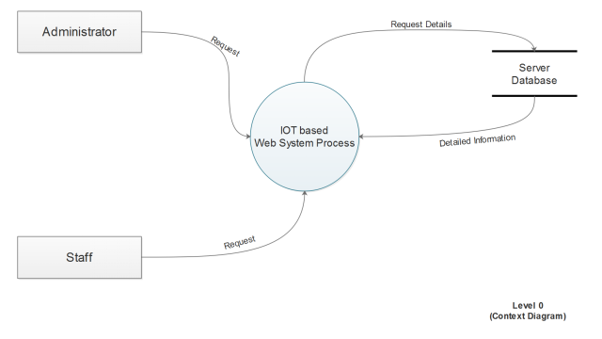

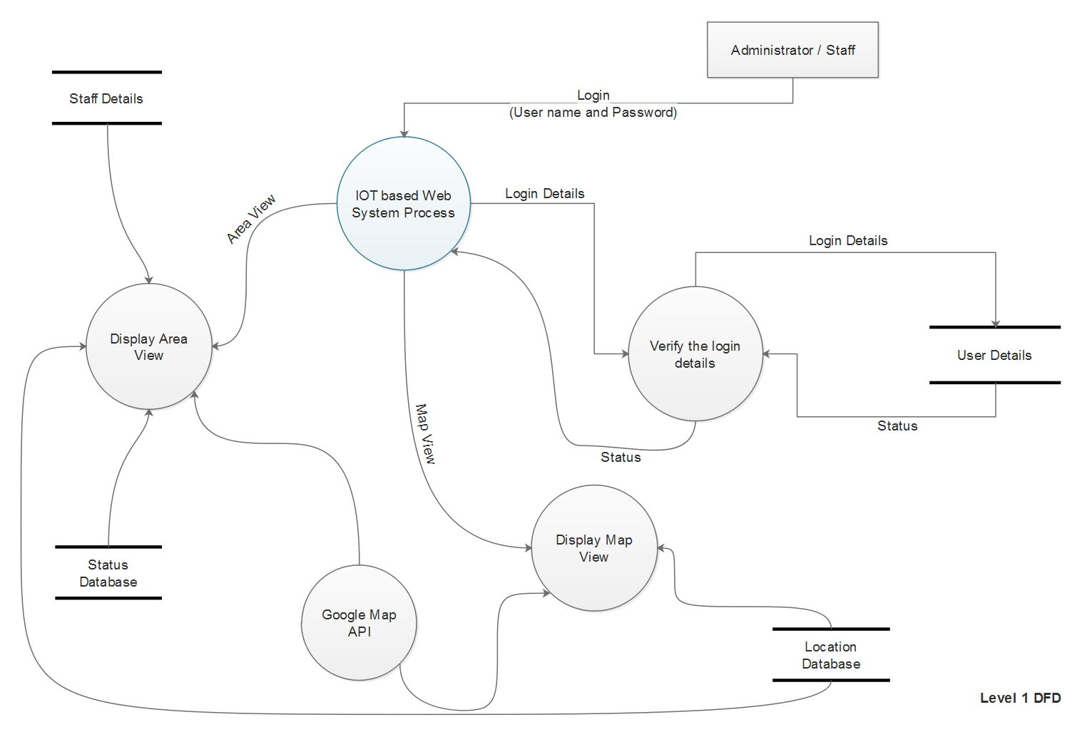

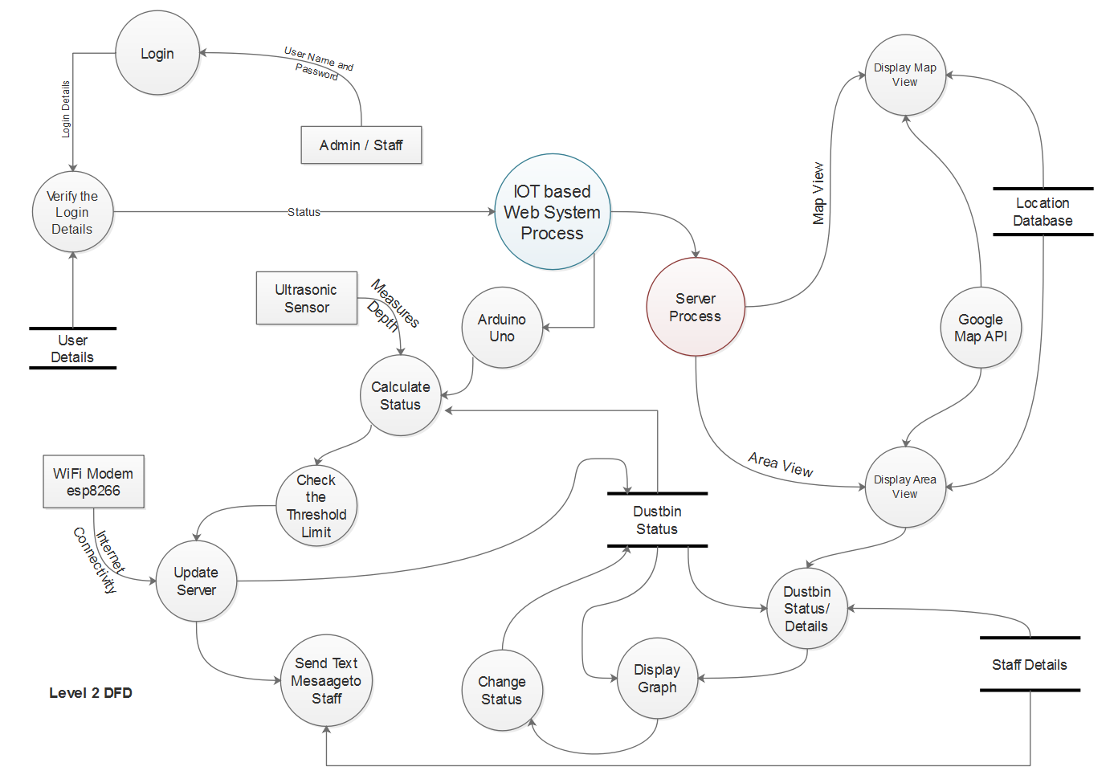

**3. PRODUCT FEATURES**

With the web application, the administrator will be able to search for dustbins. The result will be based on the criteria the user inputs. There are several search criteria and it will be possible for the administrator of the system to manage the options for those criteria that have that.

The result of the search will be viewed either in a list view or in a map view, depending on what criteria included in the search. The list view will have one list item for each dustbin matching the search criteria and show a small part of the dustbin information so the user can identify the dustbin. The administrator will be able to either select a dustbin as target destination or get information how to get there, or view the information of a specific dustbin.

The web portal will provide functionality to manage the system and the dustbin information. It will also provide information about the system, for example show when there is a new update.

A list of possible stakeholders of the system and brief description of their needs, business rules, possibilities and connections with others is presented below:

• City administration needs understanding of the big picture, generating reports, control over pricing etc.

• District administrations are interested in controlling the process of waste collection, checking quality of service (all waste collected, all in time, waste collected cleanly, waste transported to special places), quick and legal ways for solving disputes and problems.

• Municipalities can also deploy and maintain smart city infrastructure like capacity sensors in waste bins and wireless networks for data transferring.

• Waste trucks owning companies need platform for organizing and optimization of their business process in general without serious investments in developing, deploying and supporting their own system. Such system must include effective dynamic routing based on IOT data for the truck fleet. Besides, controlling drivers and tracking the fleet is also an important issue.

• Waste truck drivers need navigation system for fulfilling their tasks. Another issue is reporting problems and passing them to the operators in the office instead of thinking how to solve the problem, this can sufficiently save time of a driver and vehicle. Drivers also need evidence that their work was done correctly and cleanly.

• Managers of dumps and recycling factories can publish their possibilities or needs in acquiring certain amount of waste for storing or recycling.

• Staff that is responsible for trash bins in the current yards needs communications with waste management companies and truck drivers.

• Road police can get reports about inaccurate car parking that leads to impossibility of waste collection. • Citizens want to have better service, lower cost and having easy accessible reports on what has been done and how much it cost



* Know the fill-level of the containers at all times
* Cut the service costs by up to 50%
* Provide a world class service
* Reduce the organization’s carbon footprint
* Ultrasonic & Infrared fill-level, geo-location/GPS
* Eliminate over-filling by collecting before it could arise
* Send optimized routes directly to the drivers
* Arduino Chipset and all other sensors weigh less than 300gm & easily mounted to any container
* Ultrasonic Sensors measures up to 7.5m in depth
* Full management of the container assets and generating smart routes for the drivers (using Google maps)!
* Whenever the waste bin gets filled this is acknowledged by placing the circuit at the waste bin
* The signal is transmitted to the receiver at the desired place in the area 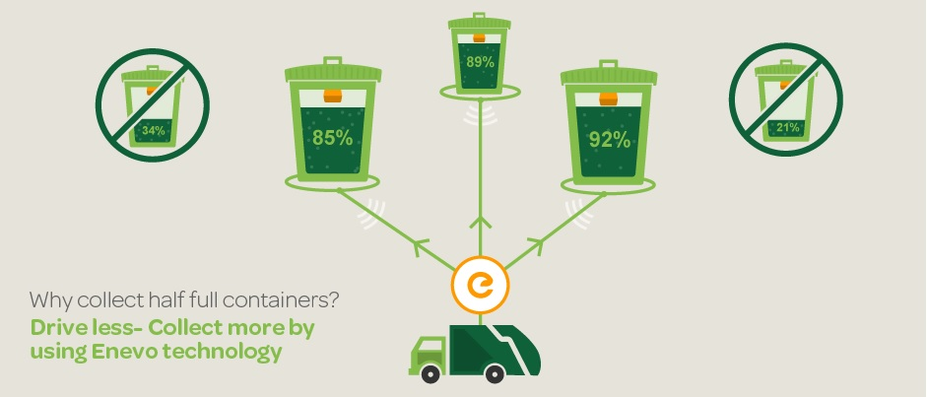

**4. FEASIBILITY AND INITIAL COSTS**

* The initial goal is to try in one city then replicate to multiple cities
* The product is designed using most open source components there by any city can scale it up and manufactured in large volume
* The system will have its own business model to create sustainable revenue
* The Cost of Arduino chip set and other hardware is minimal as compared to the service they provide
* The cost associated with the project is only at the setup of the project, as Arduino chip set, WIFI modem, ultrasonic sensors and other hardware is needed

**5. DIFFERENT MODULE**

* Administrative module
* Municipality module
* Garbage collector Driver module

**5.1 Administrator Module**

* Used by Main Administrator – Single User
* Controls all the Functionalities
* Controls the Permissions of Different Users
* Can Provide Access to new Users in other Modules

**5.2 Municipal Authority Module**

* Used by the Authority of Municipal Corporation
* Can view the GUI based Level of Garbage in the Dustbin
* Can View the Map View status of the Dustbins
* Can view the Dustbin Details – Dustbin ID, Threshold Value, Location
* Can View the Details of all the Drivers located in their Area
* Can Update the Dustbin and Drivers Details 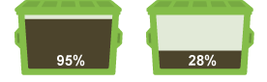

**5.3 Garbage Collector Driver Module**

* Used by the Drivers on their Smartphones
* Can View the Map View status of the Dustbins
* Can view the Dustbin Details – Dustbin ID, Threshold Limit, Location
* Informed Through Text Message when Threshold Limit Exceeds 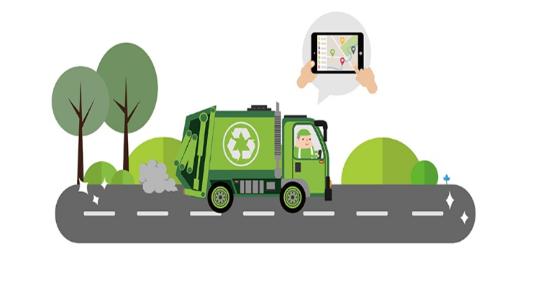**Functionality through example**

**Municipal Corporation of Delhi**

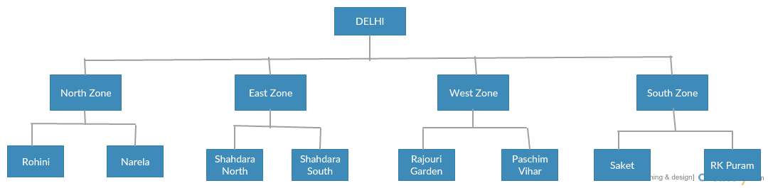

**6. HARDWARE INTERFACE:**

**6.1 Arduino Uno**

Arduino Uno is a micro controller board. It has 14 digital input/ output pins (of which 6 can be used as PWM outputs), 6 analog inputs, a 16 MHz quartz crystal, a USB connection, a power jack, an ICSP header and a reset button. It contains everything needed to support the micro controller; simply connect it to a computer with a USB cable or power it with a AC-to-DC adapter or battery to get started.. You can tinker with your UNO without worrying too much about doing something wrong, worst case scenario you can replace the chip for a few dollars and start over again.

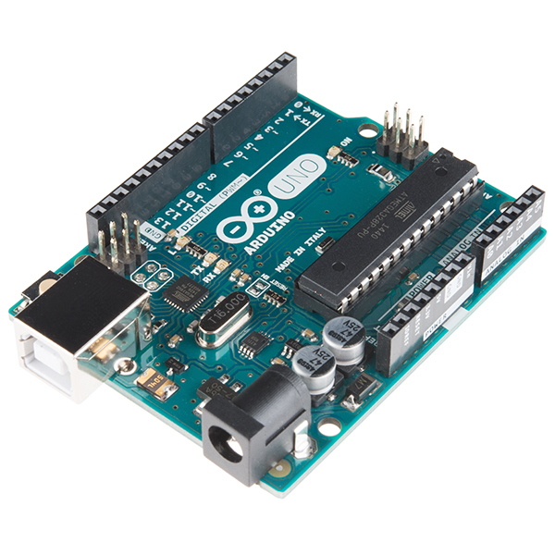

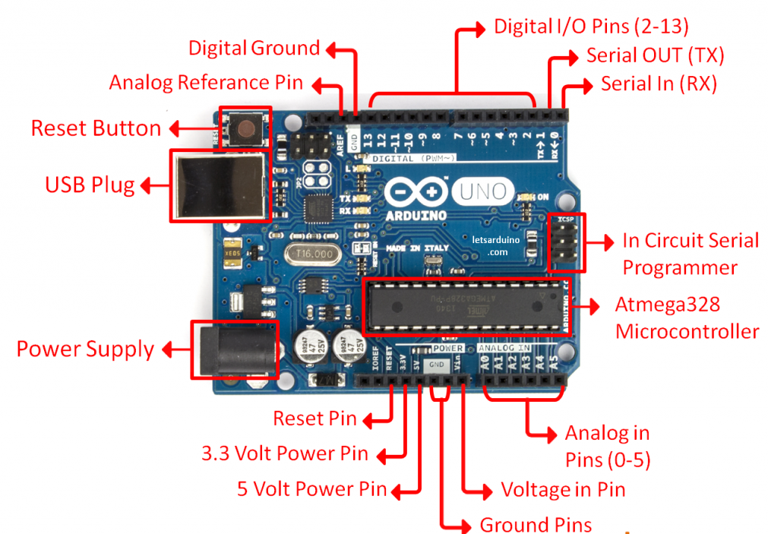

**6.2 Ultrasonic Sensor:**

The Ultrasonic Sensor sends out a high-frequency sound pulse and then times how long it takes for the echo of the sound to reflect back. The sensor has 2 openings on its front. One opening transmits ultrasonic waves, (like a tiny speaker), the other receives them, (like a tiny microphone).The speed of sound is approximately 341 meters (1100 feet) per second in air. The ultrasonic sensor uses this information along with the time difference between sending and receiving the sound pulse to determine the distance to an object.

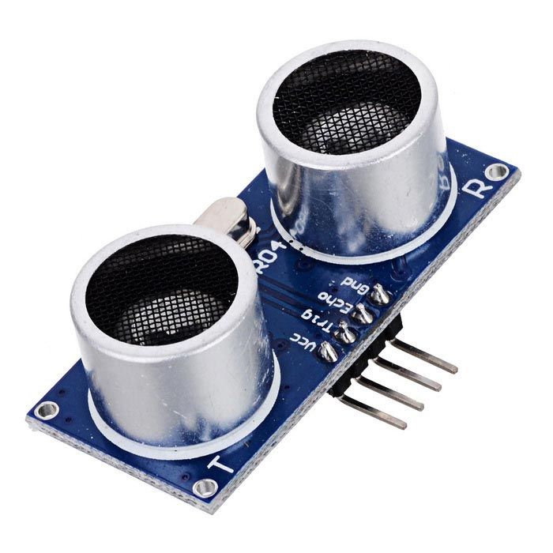

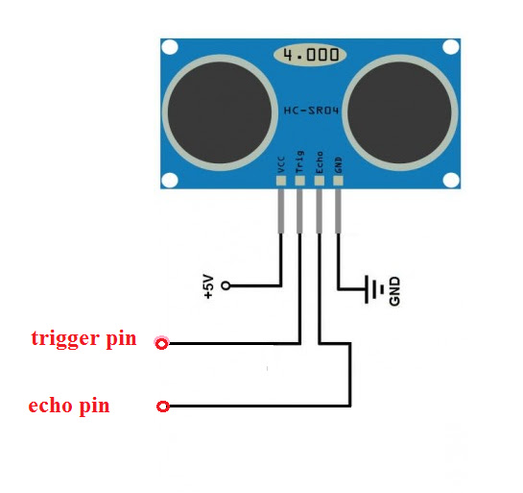

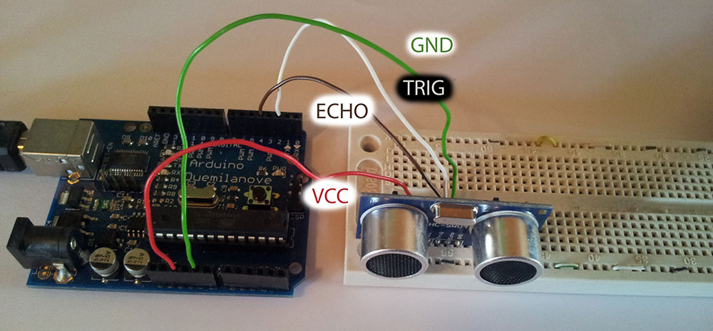

**6.3 WiFi Module – ESP8266:**

The ESP8266 WiFi Module is a self contained SOC with integrated TCP/IP protocol stack that can give any micro controller access to your WiFi network. The ESP8266 is capable of either hosting an application or offloading all Wi-Fi networking functions from another application processor. Each ESP8266 module comes pre-programmed with an AT command set firmware, meaning, you can simply hook this up to your Arduino device and get about as much WiFi-ability as a WiFi Shield offers. ? Breadboard: A breadboard is a construction base for prototyping of electronics. In the 1970’s the solder less breadboard (AKA plug board, a terminal array board) became available and nowadays the term “breadboard” is commonly used to refer to these. “Breadboard” is also a synonym for “prototype”. Because the solder less breadboard does not require soldering, it is reusable. This makes it easy to use for creating temporary prototypes and experimenting with circuit design. ? JUMPER WIRES: A jump wire is an electrical wire or group of them in a cable with a connector or pin at each end (or sometimes without them – simply “tinned”), which is normally used to interconnect the components of a breadboard or other prototype or test circuit, internally or with other equipment or components, without soldering.

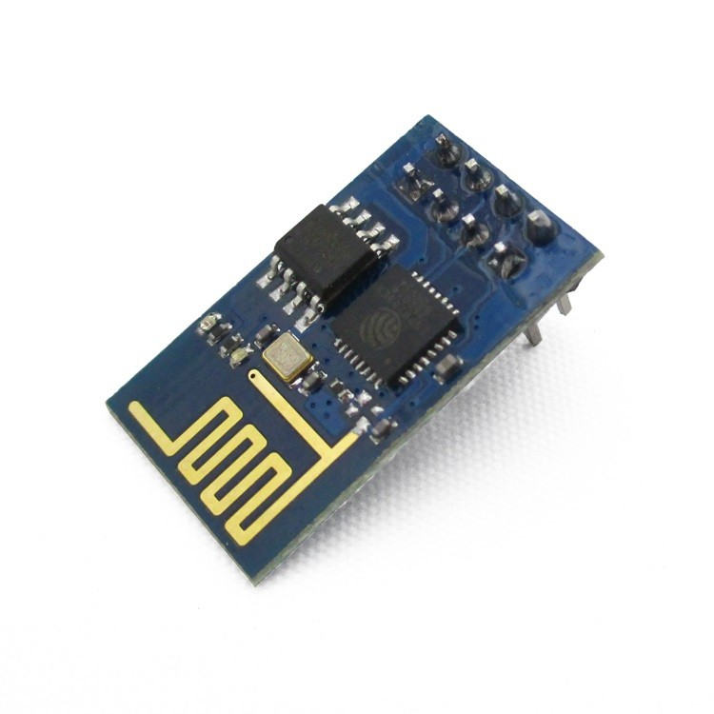

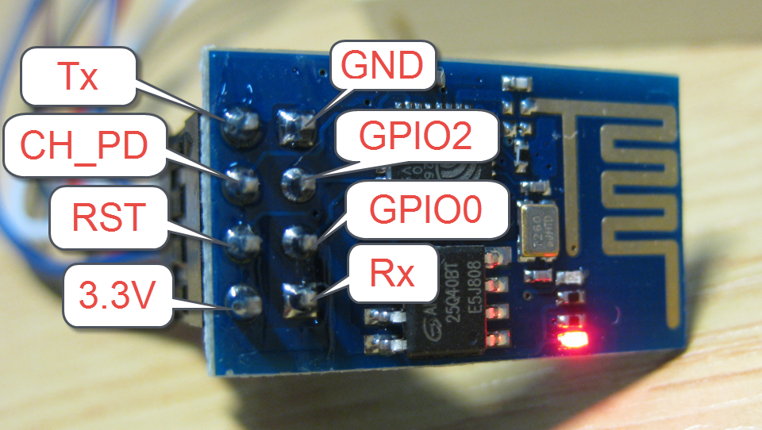

**6.4 Jumper Wires**

* Jump wire is an electrical wire or group of them in a cable with a connector or pin at each end
* It is used to interconnect the components of a breadboard
* They are of following types:

1. Male to male
2. Male to female
3. Female to female

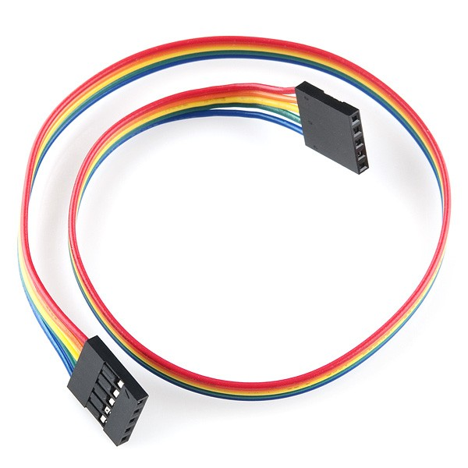

**7. SOFTWARE INTERFACE:**

**7.1 Arduino IDE:**

The open-source Arduino Software (IDE) makes it easy to write code and upload it to the board. It runs on Windows, Mac OS X, and Linux. The environment is written in Java and based on Processing and other open-source software.

This software can be used with any Arduino board. It contains a text editor for writing code, a message area, a text console, a toolbar with buttons for common functions and a series of menus.

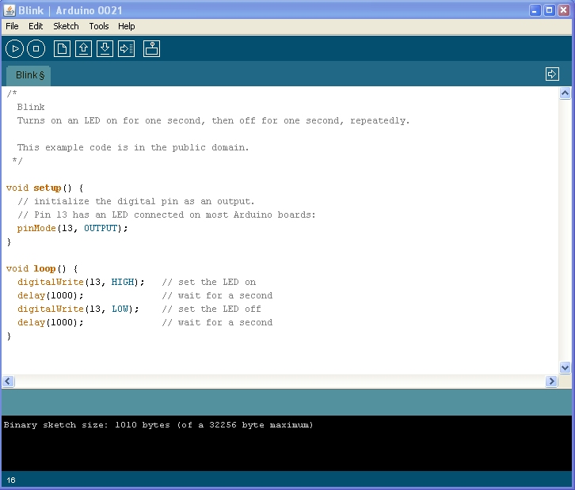

**7.2 Web Server:**

A Web server is a program that uses Hypertext Transfer Protocol to serve the files that form Web pages to users, in response to their requests, which are forwarded by their computers’ HTTP clients. Dedicated computers and appliances may be referred to as Web servers as well.

**7.3 Front end Technologies:**

HTML5:

HTML5 is a markup language used for structuring and presenting content on the World Wide Web. It is the latest and most enhanced version of HTML.

CSS3:

Cascading Style Sheets (CSS) is a style sheet language used for describing the look and formatting of a document written in a markup language.CSS3 is a latest standard of CSS.

Javascript:

JavaScript is a full-fledged dynamic programming language that, when applied to an HTML document, can provide dynamic interactivity on websites.

JQuery:

JQuery is a cross-platform JavaScript library designed to simplify the client-side scripting of HTML. JQuery is the most popular JavaScript library in use today.

**7.4 Back end Technologies**

PHP:

PHP is a server scripting language, and a powerful tool for making dynamic and interactive Web pages.

MySql:

MySQL is an open-source relational database management system (RDBMS).It is very fast, reliable, and easy to use.

**7.5 Algorithm and Code**

**For ping**

#include <ST_HW_HC_SR04.h>

const int trigPin = 2;

const int echoPin = 4;

void setup() {

Serial.begin(9600);}

void loop()

{

long duration, inches, cm;

pinMode(trigPin, OUTPUT);

digitalWrite(trigPin, LOW);

delayMicroseconds(2);

digitalWrite(trigPin, HIGH);

delayMicroseconds(10);

digitalWrite(trigPin, LOW);

pinMode(echoPin, INPUT);

duration = pulseIn(echoPin, HIGH);

inches = microsecondsToInches(duration);

cm = microsecondsToCentimeters(duration);

Serial.print(inches);

Serial.print("in, ");

Serial.print(cm);

Serial.print("cm");

Serial.println();

delay(100);

}

long microsecondsToInches(long microseconds)

{return microseconds / 74 / 2;

}

long microsecondsToCentimeters(long microseconds)

{return microseconds / 29 / 2;}

**For condition (Bucket condition)**

#include <WiFiEsp.h>

#include <WiFiEspClient.h>

#include <WiFiEspServer.h>

#include <WiFiEspUdp.h>

#include <SoftwareSerial.h> // including the library for the software serial

#define DEBUG true

SoftwareSerial esp8266(10,11); /* This will make the pin 10 of arduino as RX pin and

pin 11 of arduino as the TX pin Which means that you have to connect the TX from the esp8266

to the pin 10 of arduino and the Rx from the esp to the pin 11 of the arduino*/

const int trigPin = 8; // Making the arduino's pin 8 as the trig pin of ultrasonic sensor

const int echoPin = 9; // Making the arduino's pin 9 as the echo pin of the ultrasonic sensor

// defining two variable for measuring the distance

long duration;

int distance;

void setup()

{

Serial.begin(9600); // Setting the baudrate at 9600

esp8266.begin(9600); // Set the baudrate according to you esp's baudrate. your esp's baudrate might be different from mine

pinMode(trigPin, OUTPUT); // Setting the trigPin as Output pin

pinMode(echoPin, INPUT); // Setting the echoPin as Input pin

sendData("AT+RST\r\n",2000,DEBUG); // command to reset the module

sendData("AT+CWMODE=2\r\n",1000,DEBUG); // This will configure the mode as access point

sendData("AT+CIFSR\r\n",1000,DEBUG); // This command will get the ip address

sendData("AT+CIPMUX=1\r\n",1000,DEBUG); // This will configure the esp for multiple connections

sendData("AT+CIPSERVER=1,80\r\n",1000,DEBUG); // This command will turn on the server on port 80

}

void loop()

{

digitalWrite(trigPin, LOW); // Making the trigpin as low

delayMicroseconds(2); // delay of 2us

digitalWrite(trigPin, HIGH); // making the trigpin high for 10us to send the signal

delayMicroseconds(10);

digitalWrite(trigPin, LOW);

duration = pulseIn(echoPin, HIGH); // reading the echopin which will tell us that how much time the signal takes to come back

distance= duration*0.034/2; // Calculating the distance and storing in the distance variable

if(esp8266.available()) // This command will that check if the esp is sending a message

{

if(esp8266.find("+IPD,"))

{

delay(1000);

int connectionId = esp8266.read()-48; /* We are subtracting 48 from the output because the read() function returns

the ASCII decimal value and the first decimal number which is 0 starts at 48*/

String webpage = "<h1>IOT Garbage Monitoring System</h1>";

webpage += "<p><h2>";

if (distance<5)

{

webpage+= " Trash can is Full";

}

else{

webpage+= " Trash can is Empty";

}

webpage += "</h2></p></body>";

String cipSend = "AT+CIPSEND=";

cipSend += connectionId;

cipSend += ",";

cipSend +=webpage.length();

cipSend +="\r\n";

sendData(cipSend,1000,DEBUG);

sendData(webpage,1000,DEBUG);

String closeCommand = "AT+CIPCLOSE=";

closeCommand+=connectionId;

closeCommand+="\r\n";

sendData(closeCommand,3000,DEBUG);

}

}

}

String sendData(String command, const int timeout, boolean debug)

{

String response = "";

esp8266.print(command);

long int time = millis();

while( (time+timeout) > millis())

{

while(esp8266.available())

{

char c = esp8266.read();

response+=c;

}

}

if(debug)

{

Serial.print(response);

}

return response;

}

const int trigPin = 2;

const int echoPin = 4;

void setup() {

Serial.begin(9600);}

void loop()

{

long duration, distance, inches, cm;

pinMode(trigPin, OUTPUT);

digitalWrite(trigPin, LOW);

delayMicroseconds(2);

digitalWrite(trigPin, HIGH);

delayMicroseconds(10);

digitalWrite(trigPin, LOW);

pinMode(echoPin, INPUT);

duration = pulseIn(echoPin, HIGH);

distance= duration*0.034/2;

if (distance<10)

{

Serial.print(" Trash can is Full");

}

else{

Serial.print(" Trash can is empty");

}

inches = microsecondsToInches(duration);

cm = microsecondsToCentimeters(duration);

Serial.print(inches);

Serial.print("in, ");

Serial.print(cm);

Serial.print("cm");

Serial.println();

delay(100);

}

long microsecondsToInches(long microseconds)

{return microseconds / 74 / 2;

}

long microsecondsToCentimeters(long microseconds)

{

return microseconds / 29 / 2;

}

Output:

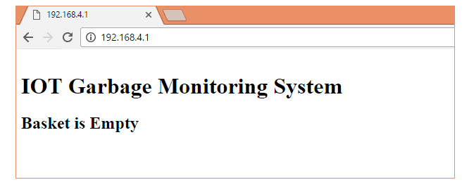

**8. Application**

The project designed is a part of the implication that can be used to improve the waste management of a locality. All the technical aspects have been thoroughly designed keeping all the constraints in mind. The project resolves around whether the project will be able to meet the future needs of the users. This project based on IOT gives user the freedom of changing hardware as well as software specifications as per the arising need. IOT based projects are already designed while keeping future demands in mind and in rising economy like India where the concept of smart cities is new the demand of our project will keep on increasing. This project here is a model of the large scale application which spans pan India in different smart cities. Implementation of this project has been divided into various phases. Starting from the metropolitan cities and moving towards the concept of smart cities, it will also cover small town and tier III cities in later phases. At present, we are here to display the live working of the model and give an idea about the actual implications. For any society to flourish, it is manifestly important that they remain fair and orderly. Deciding how best to ensure this, in light of the huge growth in both the uptake and complexity of technology that has occurred in the last decade, and which can be expected to continue in the next, this here is one of the product that can be used to contribute to the better management of waste and increase efficiency of resources.

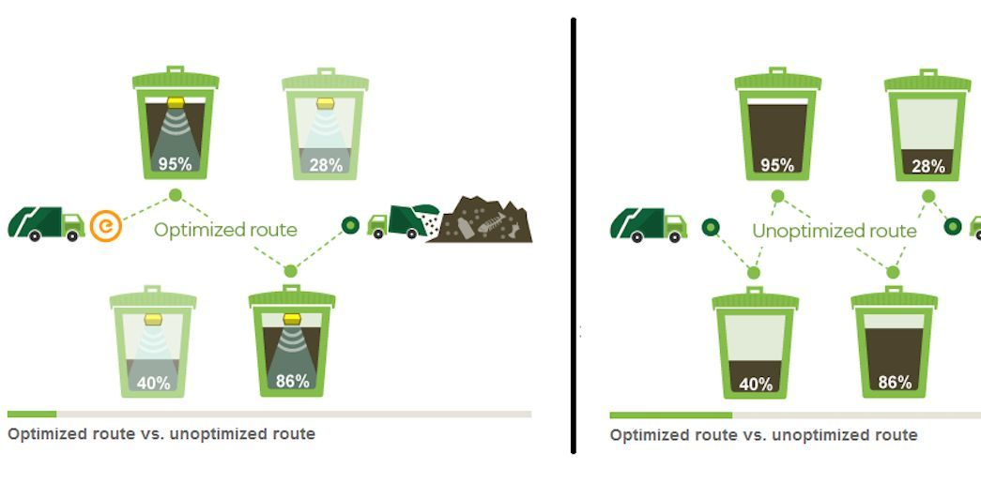

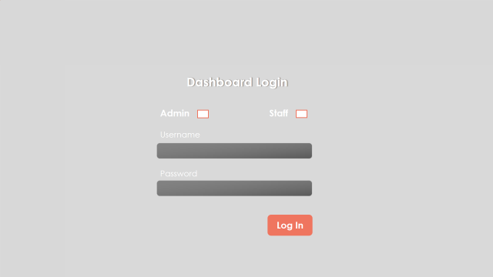

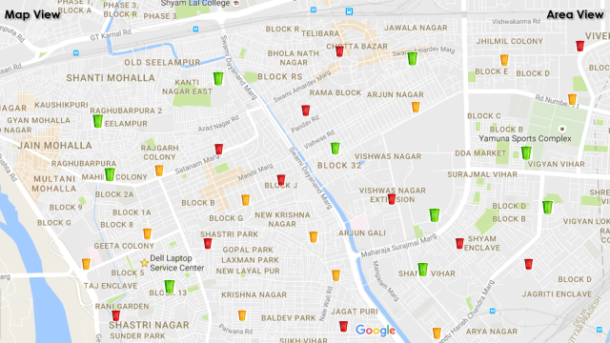

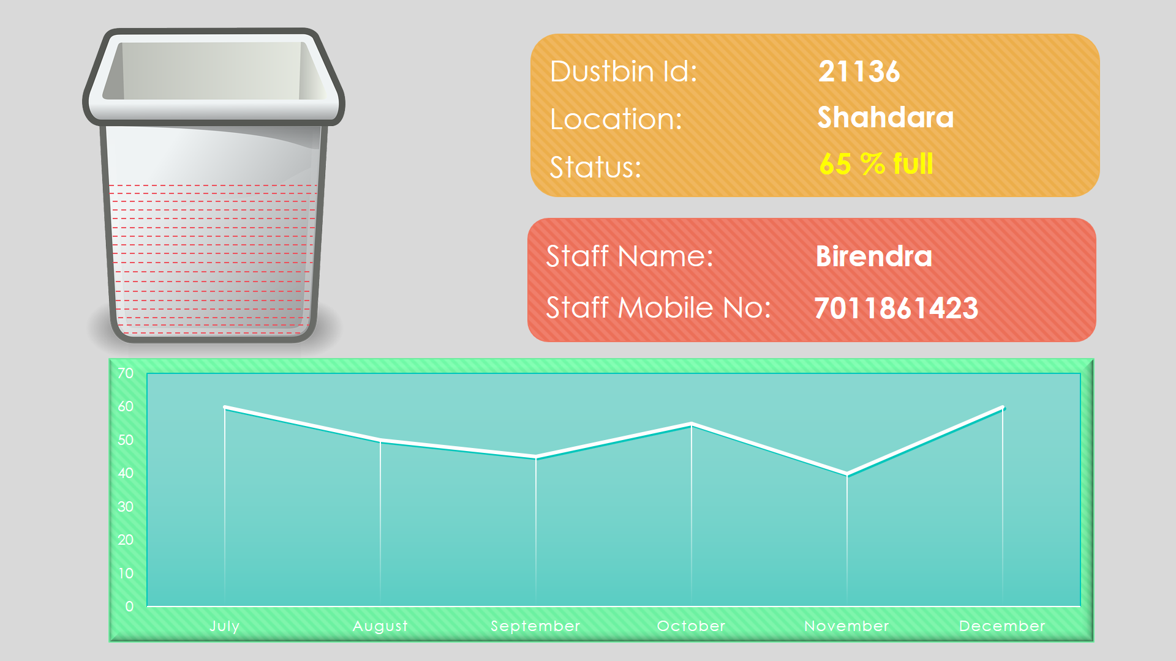

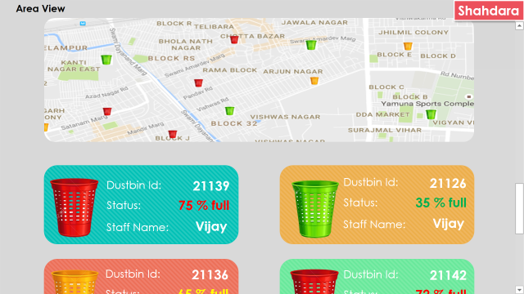

**9. Limitations**



* Availability of resources: The setup of the project requires an Arduino chip set, WIFI modem, ultrasonic sensors and other hardware are needed.
* Trial and testing of the project requires specific environment and labs equipped with proper facilities.
* Implementation of the project requires prescriptive regulations to be legally and operationally enforceable.
* Scope of the project: The project can be implemented only in the metropolitan cities and some tier II cities. Small towns and tier III cities are out of the bound as technical feasibility is not possible.
* Effective management of human resources: Skilled and trained people are required to operate the whole mechanism.

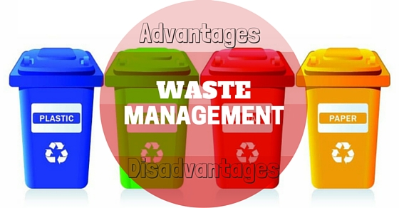

**10. Advantages**

* Reduce the cost and complexity of the edge devices.
* Gateway can act as hub for things with different data standards and wireless protocols that provide uniform face to the devices.
* Easy to control and monitor as the whole system is centralized.
* Gateway can control what data to be sent to the internet and provide information security
* Convinient to link legacy equipment into the IoT.

**11. Disadvantage**

* One of more tier will add higher complexity in the integration
* Resources still reside locally comparing with using cloud technology
* As the system is centralized, failure of central hub will bring down the network
* Disposal of e waste generates toxic substances which is harmful to both environment and humans.
* Implementing the system on a broad level will take require a lot resources both financially and technically

**CONCLUSION**

The project resolves around whether the project will be able to meet the future needs of the users. This project based on IOT gives user the freedom of changing hardware as well as software specifications as per the arising need. IOT based projects are already designed while keeping future demands in mind and in rising economy like India where the concept of smart cities is new the demand of our project will keep on increasing. This project here is a model of the large scale application which spans pan India in different smart cities. Implementation of this project has been divided into various phases. Starting from the metropolitan cities and moving towards the concept of smart cities, it will also cover small town and tier III cities in later phases. At present, we are here to display the live working of the model and give an idea about the actual implications. For any society to flourish, it is manifestly important that they remain fair and orderly. Deciding how best to ensure this, in light of the huge growth in both the uptake and complexity of technology that has occurred in the last decade, and which can be expected to continue in the next, this here is one of the product that can be used to contribute to the better management of waste and increase efficiency of resources.

**BIBLOGRAPHY**

**WEBSITES:**

1.<https://www.researchgate.net/publication/282934154_Smartbin_Smart_waste_management_system>

2.<https://create.arduino.cc/projecthub/silicon-ripley-10/distance-measurement-using-ultrasonic-sensor-and-arduino-9bacd4?ref=tag&ref_id=ultrasonic&offset=13>

3.http://www.instructables.com/id/IoT-ESP8266-Series-1-Connect-to-WIFI-Router/

4. <http://www.geeks.org/project-idea-smart-waste-management-system/>